**Latihan Modul 5**

**Nama : Farhan**

**NIM : 215031**

**Kelas : 1RLAL-A / Prak. Algoritma & Pemograman**

**II.3.2 Percobaan II-2: Operator pembanding**

**Script :**

/* Percobaan II-2: Operator pembanding

* percobaan202.cpp */

#include <iostream>

**using namespace** std;

**int** main()

{

**int** m = 5, n = 7;

**if**(m == n)

cout << m << **" sama dengan "** << n << endl;

**else if**(m != n)

cout << m << **" tidak sama dengan "** << n << endl;

**else if**(m > n)

cout << m << **" lebih besar "** << n << endl;

**else if**(m < n)

cout << m << **" lebih kecil "** << n << endl;

return 0;

}

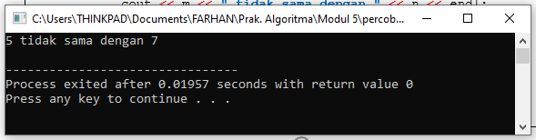**Output:**

**Script Penambahan Komentar :**

/* Percobaan II-2: Operator pembanding

* percobaan202.cpp */

#include <iostream>

**using namespace** std;

**int** main()

{

**int** m = 5, n = 7;

**if**(m == n)

cout << m << **" sama dengan "** << n << endl;

//else if(m != n)

// cout << m << " tidak sama dengan " << n << endl;

**else if**(m > n)

cout << m << **" lebih besar "** << n << endl;

**else if**(m < n)

cout << m << **" lebih kecil "** << n << endl;

return 0;

}

***\*Perubahan pada highlighting kuning***

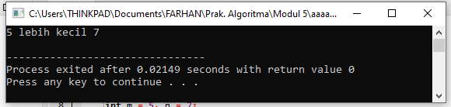**Output Setelah Penambahan Komentar :**

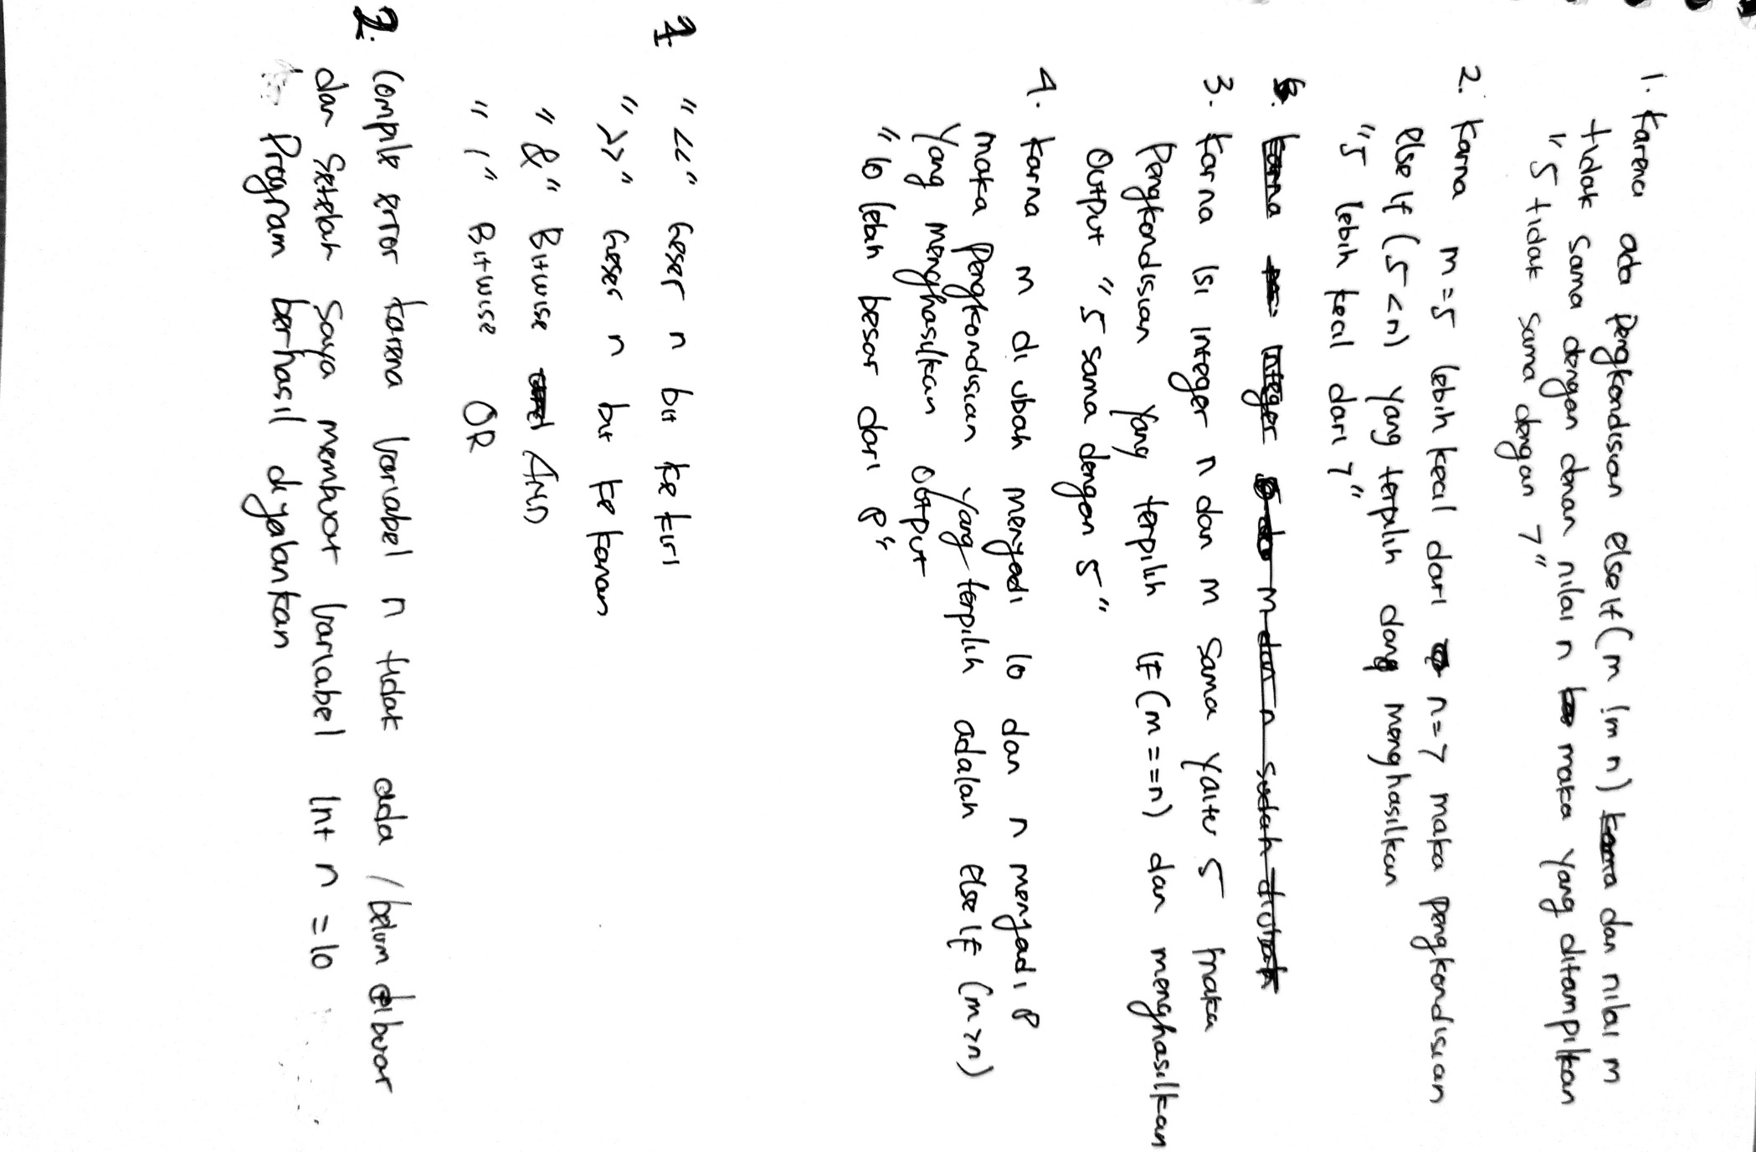

**Soal :**

**II.3.3 Percobaan II-3: Operator bitwise**

**Script :**

/* Percobaan II-2: Operator pembanding

* percobaan203.cpp */

#include <iostream>

**using namespace** std;

**int** main()

{

**int** m = 90;

cout << m << " << 2 " << " = " << (m<<2) << endl;

cout << m << " >> 1 " << " = " << (m>>1) << endl;

cout << m << " & " << n << " = " << (m&n) << endl;

cout << m << " i " << n << " = " << (m|n) << endl;

return 0;

}

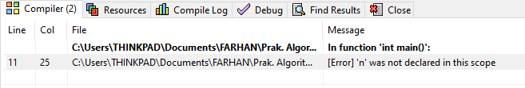**Output Error:**

**Script Penambahan Integer n :**

/* Percobaan II-2: Operator pembanding

* percobaan203.cpp */

#include <iostream>

**using namespace** std;

**int** main()

{

**int** m = 90;

**int** n = 10; //Varibel Baru

cout << m << " << 2 " << " = " << (m<<2) << endl;

cout << m << " >> 1 " << " = " << (m>>1) << endl;

cout << m << " & " << n << " = " << (m&n) << endl;

cout << m << " i " << n << " = " <<< < (m|n) << endl;

return 0;

}

***\*Perubahan pada highlighting kuning***

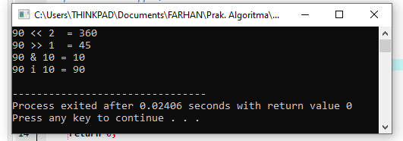**Output Setelah Ditambah Variable Integer n :**

**Soal :**

**II.3.4 Percobaan II-4: Operator logika**

**Script :**

/* Percobaan II-4: Operator logika

* percobaan204.cpp */

#include <iostream>

**using namespace** std;

**int** main()

{

**int** m = 90;

cout << "(m >= 0) && (m <= 80) -->" << (m >= 0) && (m <= 80); endl;

cout << "(m >= 0) || (m <= 80) -->" << (m >= 0) || (m <= 80); endl;

return 0;

}

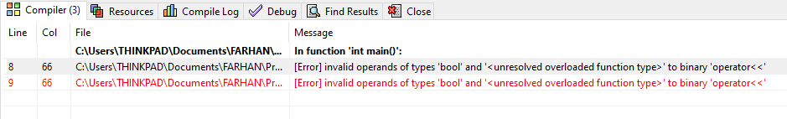**Output Error :**

**Script Penambahan ( ) Pada Logika Operator :**

/* Percobaan II-4: Operator logika

* percobaan204.cpp */

#include <iostream>

**using namespace** std;

**int** main()

{

**int** m = 90;

cout << "(m >= 0) && (m <= 80) -->" << ((m >= 0) && (m <= 80)) << endl;

cout << "(m >= 0) || (m <= 80) -->" << ((m >= 0) || (m <= 80)) << endl;

return 0;

}

***\*Perubahan pada highlighting kuning***

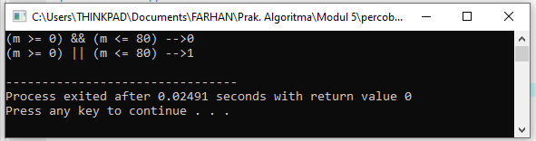**Output Setelah Perubahan :**

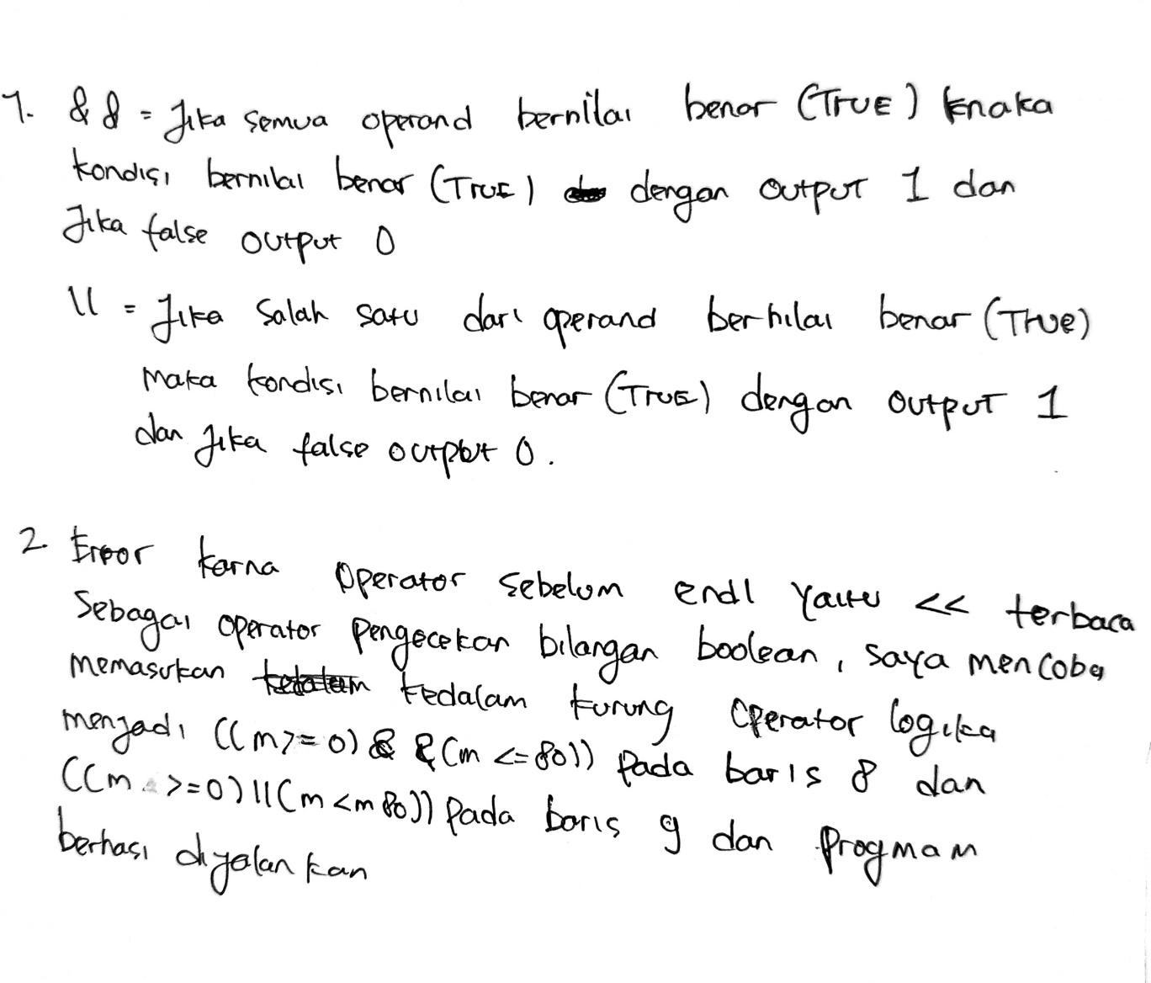**Soal:**